**Week 6 Assignment**

Writing a yaml file to Deploy a basic Nginx Pod

Apply the configuration and Verify the deployment:

Using Describe Command to check events:

Port Forwarding to 8080 to see the Webpage:

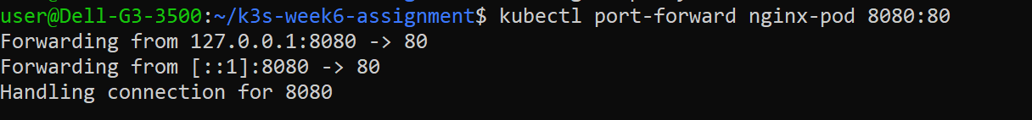

Updating the Yaml file again to add the liveness Probe:

Checking if the Probe working or not and confirming that the logs are written on the host path we have chosen:



A Config file has been created to create the /healthnz because when trying to use it in the pod yaml file it generates an error because it can not find the file. I don’t know if this is the correct method to solve this problem.